RESOLUTION NO.__________

RE: CERTIFICATE OF APPROPRIATENESS UNDER THE
PROVISIONS OF THE ACT OF THE PENNSYLVANIA
LEGISLATURE 1961, JUNE 13, P.L. 282 (53
SECTION 8004) AND BETHLEHEM ORDINANCE NO.
3952 AS AMENDED.

WHEREAS, it is proposed to install an awning and repaint the storefront trim at 530 Main St.

NOW, THEREFORE, BE IT RESOLVED by the Council of the City of Bethlehem that a Certificate of Appropriateness is hereby granted for the proposal.

Sponsored by: (s)

(s)

ADOPTED BY COUNCIL THIS DAY OF

(s)
President of Council

ATTEST:

(s)
City Clerk

HISTORICAL & ARCHITECTURAL REVIEW BOARD

The applicant is proposing to install an awning and repaint the storefront trim at 530 Main St.
APPLICATION #1:

Steve Holloman
P.O. Box 1024
Bethlehem, PA 18018

OWNER:

__________________________________________________________________________

The Board upon motion by Phil Roeder and seconded by Connie Glagola adopted the proposal that City Council issue a Certificate of Appropriateness for the following:

- The awning will have a scalloped bottom edge with lettering as submitted.

- Colors will be submitted to Mr. Donovan for approval.

- The profile will match the slope of the neighboring awning.

- Mounted high enough to clear the decorative wooden brackets with closed ends.

5. The motion was unanimously approved.
__________________________________________________________________________

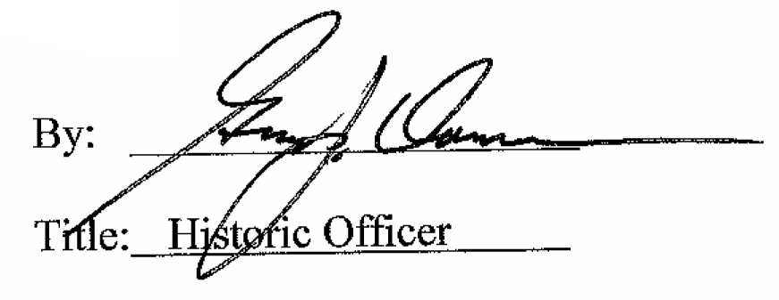

Date of Meeting: February 1, 2017

